Tessella Project Number: 7567
Tessella plc 26 The Quadrant, Abingdon Science Park, Abingdon, Oxfordshire, OX14 3YS, UK
T: +44 (0)1235 555511 | F: +44 (0)1235 553301 | E: info@tessella.com | www.tessella.com

Client: STFC

Mantid
Stakeholder Engagement Plan



Document Control
This document is under document control. All members of the distribution list will receive updated copies whenever alterations are made. All other copies are uncontrolled.

Document Owner
Name | Role | Company
Nicholas Draper | Owner | Tessella

Document Approval
The following are required to approve this document. Their approval signifies that the document is fit for purpose and approved for use.
Name | Approval Role | Company
Richard Layne | Account Manager | Tessella

Distribution
Name | Role | Company
Mantid 2013 RFP submission |  | STFC
Notes Projects Database 7567 | Archive | Tessella

Revision History
Author | Issue | Date | Description
Keith Norman |  | 03 Dec 2012 | 1st version written from QP 6870

References
Document | Ref | Date | Details & Issue

Table of Contents
1 Stakeholder Engagement Plan 3
1.1 Project Team 3
1.2 Project Communication 3

Stakeholder Engagement Plan

Project Team
The following tables show the roles fulfilled by named individuals for the project.
ISIS Management Staff
Role | Name
Client Superintending Officer, Lead Scientist | Jon Taylor
Project Sponsor, PMB Chairman | Toby Perring
Project Customer, PMB member | Sean Langridge

ORNL Managemenr Staff
Role | Name
Director of Scientific Computing, PMB member | Thomas Proffen
Head of Scientific Computing, PMB member | Mark Hagen
NCCS project manager, PMB member | Galen Shipman

Tessella Project Team Staff
Role | Name
Project manager | Nick Draper
ISIS Technical Lead | Martyn Gigg
Senior Developer | Roman Tolchenov
Senior Developer | Owen Arnold
ORNL Technical Lead | Russell Taylor

ISIS Mantid Developers
Role | Name
Developer, PMB Secretary | Anders Markvardsen
Developer | Gessner Passos
Developer | Karl Palmen
Inelastic Developer | Alex Buts
Student Developer | Tendaki Kashere

ORNL Mantid Developers
Role | Name
Team Leader | Stuart Campbell
Team Leader | Peter Peterson
Team Leader | Mathieu Doucet
Developer | Michael Reuter
Developer | Andre Savici
Developer | Vickie Lynch
Developer | Dennis/Ruth Mikkleson
Developer | Wenduo Zhuo
Developer | Shelly Ren
Developer | Jean Bilheaux
Developer | Jose Borreguero
NCCS developer | Ross Miller

Other Tessella Stakeholders
Role | Name
Project Manager’s Manager | Paul Harrop
Project Sales Person | Richard Layne
PMB member | Nigel Chown
.

Wider Stakeholders
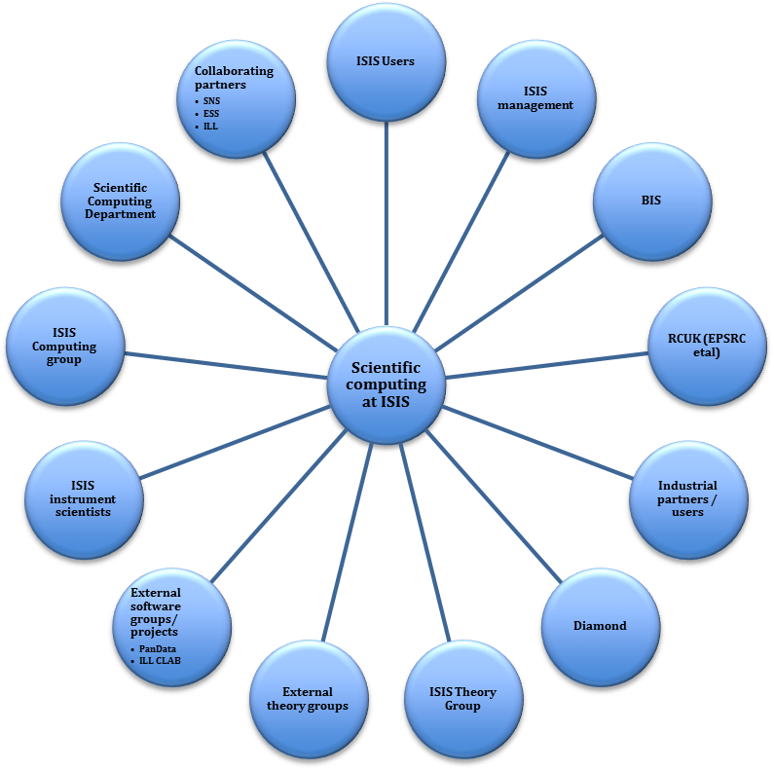
Group | Communication Path
ISIS Users | Via Instrument Scientists, however this needs to be suplimented with direct communication with nominated users, presentations at user meetings, and usability testing while users are present on experiments.
ISIS Management | Via Project Management Board, ISIS project mamagement committee, and Scientific Steering Committee (see below)
BIS | Via RCUK and ISIS Management
RCUK (EPSRC et al) | Tessella Account Manager, with Softcat Account Manager as appropriate
Industrial Partners/Users | Via Instrument Scientists, also see the communication path for ISIS users.
Diamond | Direct contact between development team (eg, NoBUGS conference), plus ongoing contact from Tessella Project Manager and Tessella Account Manager. Further directed meetings as required.
ISIS Theory Group | Via Scientific Steering Committee, also directed meetings as required to integrate simulation data into Mantid
External Theory Groups | Via ISIS Theory group
External software groups/projects | Direct contact between development team (eg, NoBUGS conference), plus ongoing contact from Tessella Project Manager and Tessella Account Manager
ISIS Instrument Scientists | Scientific Steering Committee, Tessella Project Manager engages directly at key times (eg, testing of specific functionality), ad hoc access to PM and development te3am for problem solving, working together on new functionality.
ISIS Computing Group | Scientific Steering Committee ,Tessella Project Manager engages directly at key times (eg, testing of specific functionality)
Scientific Computing Department | Via Scientific Steering Committee, also directed meetings as required to integrate simulation data into Mantid
Collaborating Partners | Via Scientific Steering Committee (see below), and Tessella Project Manager has ongoing contact (see below for SNS contact plan as an example, although it is expected that the collaborating partners may increase over the next few years as Mantid gains more acceptance)

Project Communication

Stakeholder Communication Plan for Key Individuals
Name: | Jon Taylor
Responsibility: | Superintending Officer
Comm. Path: | Meetings monthly when Jon is available to update on the project progress and assign future tasks. Meeting minutes sent when he is off site. Frequent informal contact.
Tessella Staff: | Nick Draper

Name: | Toby Perring
Responsibility: | Project Sponsor
Comm. Path: | Monthly informal contact to update on project progress. Involvement with requirements and requirements approval process.
Tessella Staff: | Nick Draper

Name: | Tim Charlton, Alan Soper, Sean Langridge, Timmy Ramirez-Cuesta, Arwell Hughes, Francis Pratt, Toby Perring, Freddie Akeroyd, Jon Taylor, Russell Ewings, Pascal Manuel,
Responsibility: | Scientific Steering Committee
Comm. Path: | Quarertly scientific steering committee meetings, further smaller meetings as required
Tessella Staff: | Nick Draper

Name: | Robert McGreevy, Sean Langridge, Jon Taylor, Toby Perring, Nigel Chown, Mark Hegen, Galen Shipman, Thomas Proffen
Responsibility: | Project Management Board
Comm. Path: | Meetings every 4 months
Tessella Staff: | Nick Draper

Name: | Stuart Campbell, Peter Peterson, Mathieu Doucet
Responsibility: | SNS team leads
Comm. Path: | Weekly working group skype teleconferences
Tessella Staff: | Nick Draper

